ngSwitch, ngIf, ngFor = Structural directives

ngClass , ngStyle – attribute directives

to bring app.module.ts

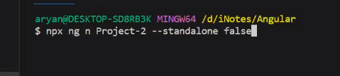

A directive is something which unlike component doesn’t have have html & css of its own.

To create a directive , ng g d <directive-name> , where d for directive

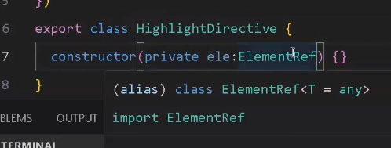

We are able to inject another class ElementRef inside our directive HighLight Directive

Home work:

ng add @ng-bootstrap/ng-bootstrap

-------------------------------------------------------

import { NgbModule } from '@ng-bootstrap/ng-bootstrap';

@NgModule({

imports: [

NgbModule,

// other imports...

],

// declarations, bootstrap, etc.

})

export class AppModule { }

--------------------------------------------------------------

import { Component } from '@angular/core';

@Component({

selector: 'app-root',

template: `

<div>

<input

type="text"

[value]="inputData"

[title]="inputData"

(input)="onInputChange($event)"

[ngbTooltip]="inputData"

/>

</div>

`,

styles: [`

div {

padding: 20px;

}

`]

})

export class AppComponent {

inputData: string = '';

onInputChange(event: any) {

this.inputData = event.target.value;

}

}

To create a service , ng g s <service-name> , where s for service